**Tableau Analysis**

1.How has the online sales changed over years? Is there any interesting trend that is observed?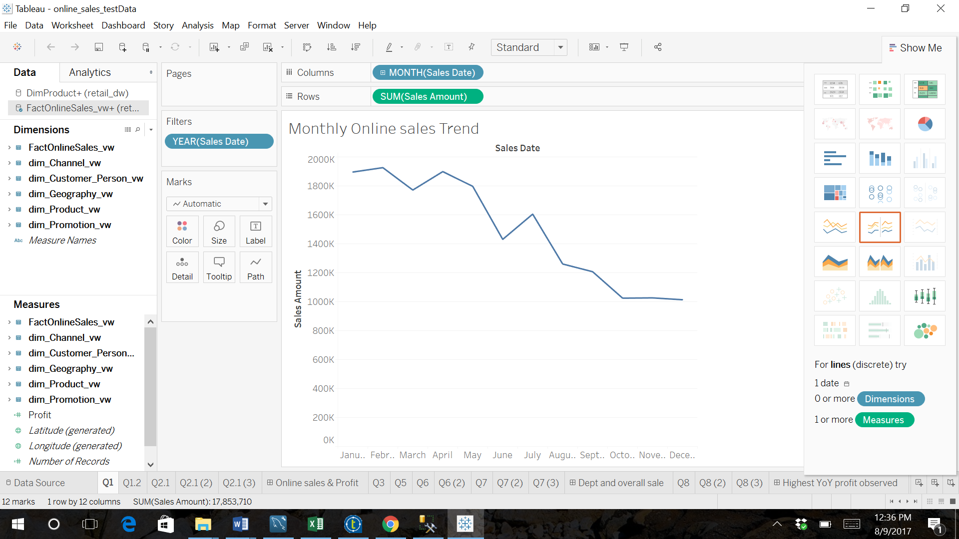

Figure : Montly Online sales trend month-wise

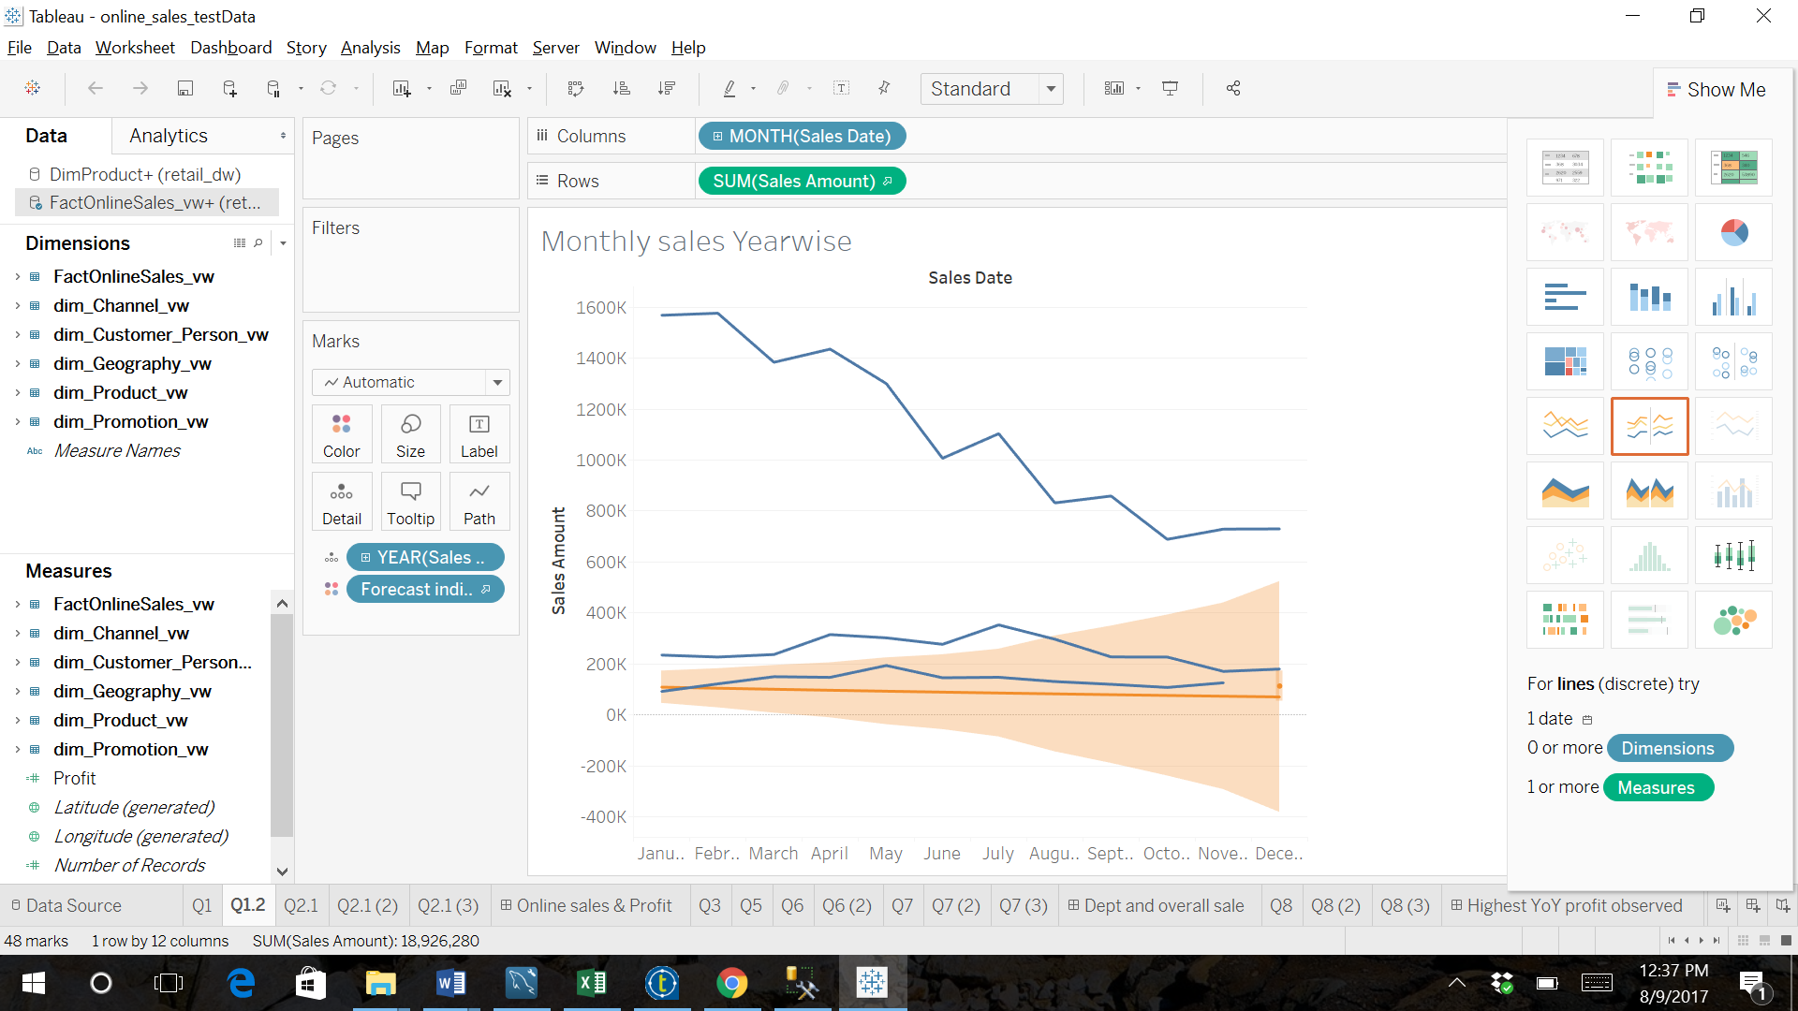

Figure : Monthly Online Sales trend year-wise

2.How has the online sales profit changed over years? Is there any interesting trend that is observed?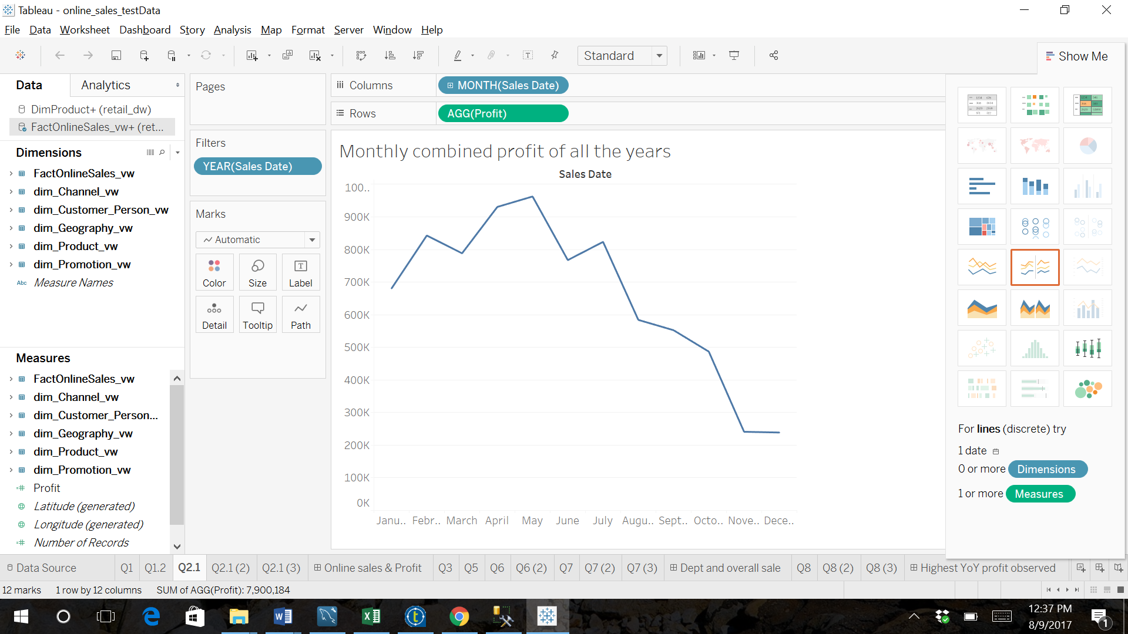

Figure : Mponthly Online sales trend combined year-wise

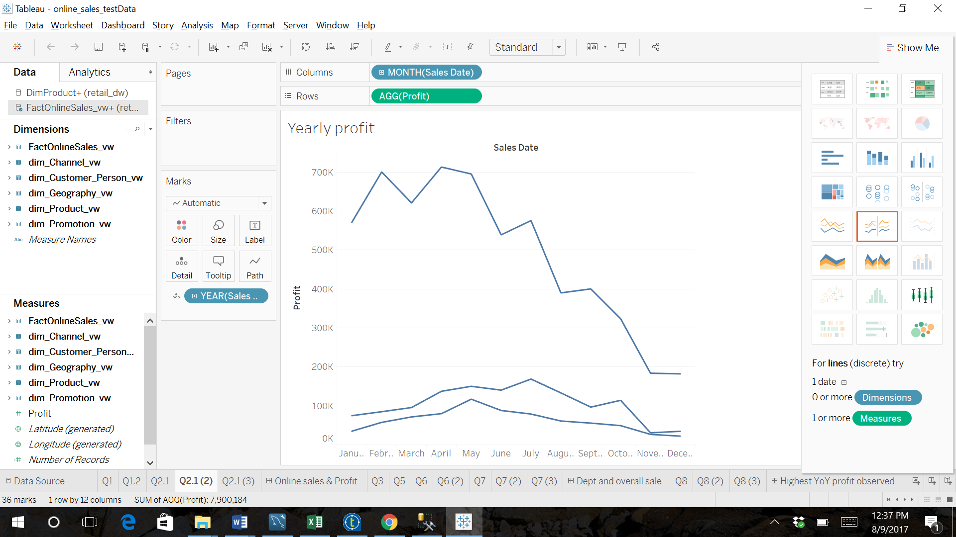

Figure : Yearly profit

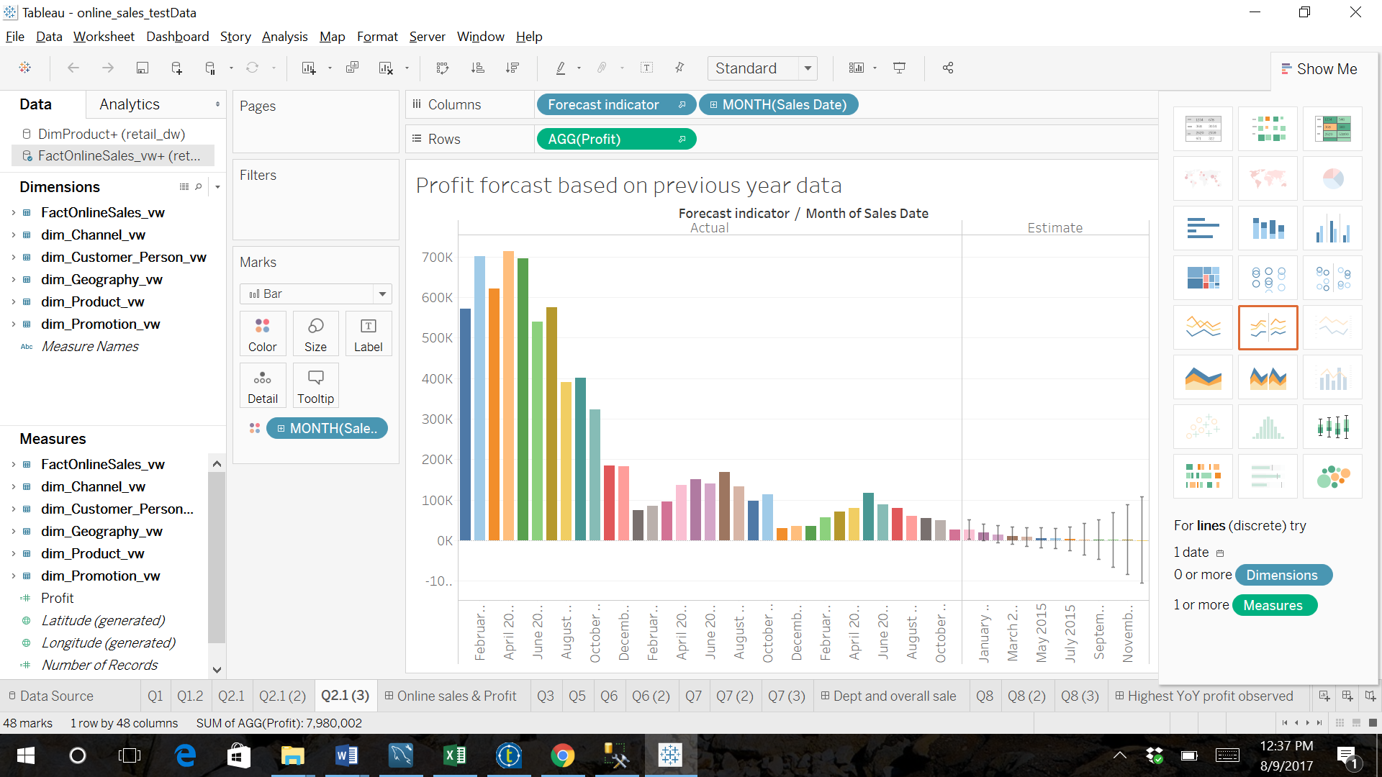

Figure : Monthly profit forecasted

Dashboard for Question 1 & 2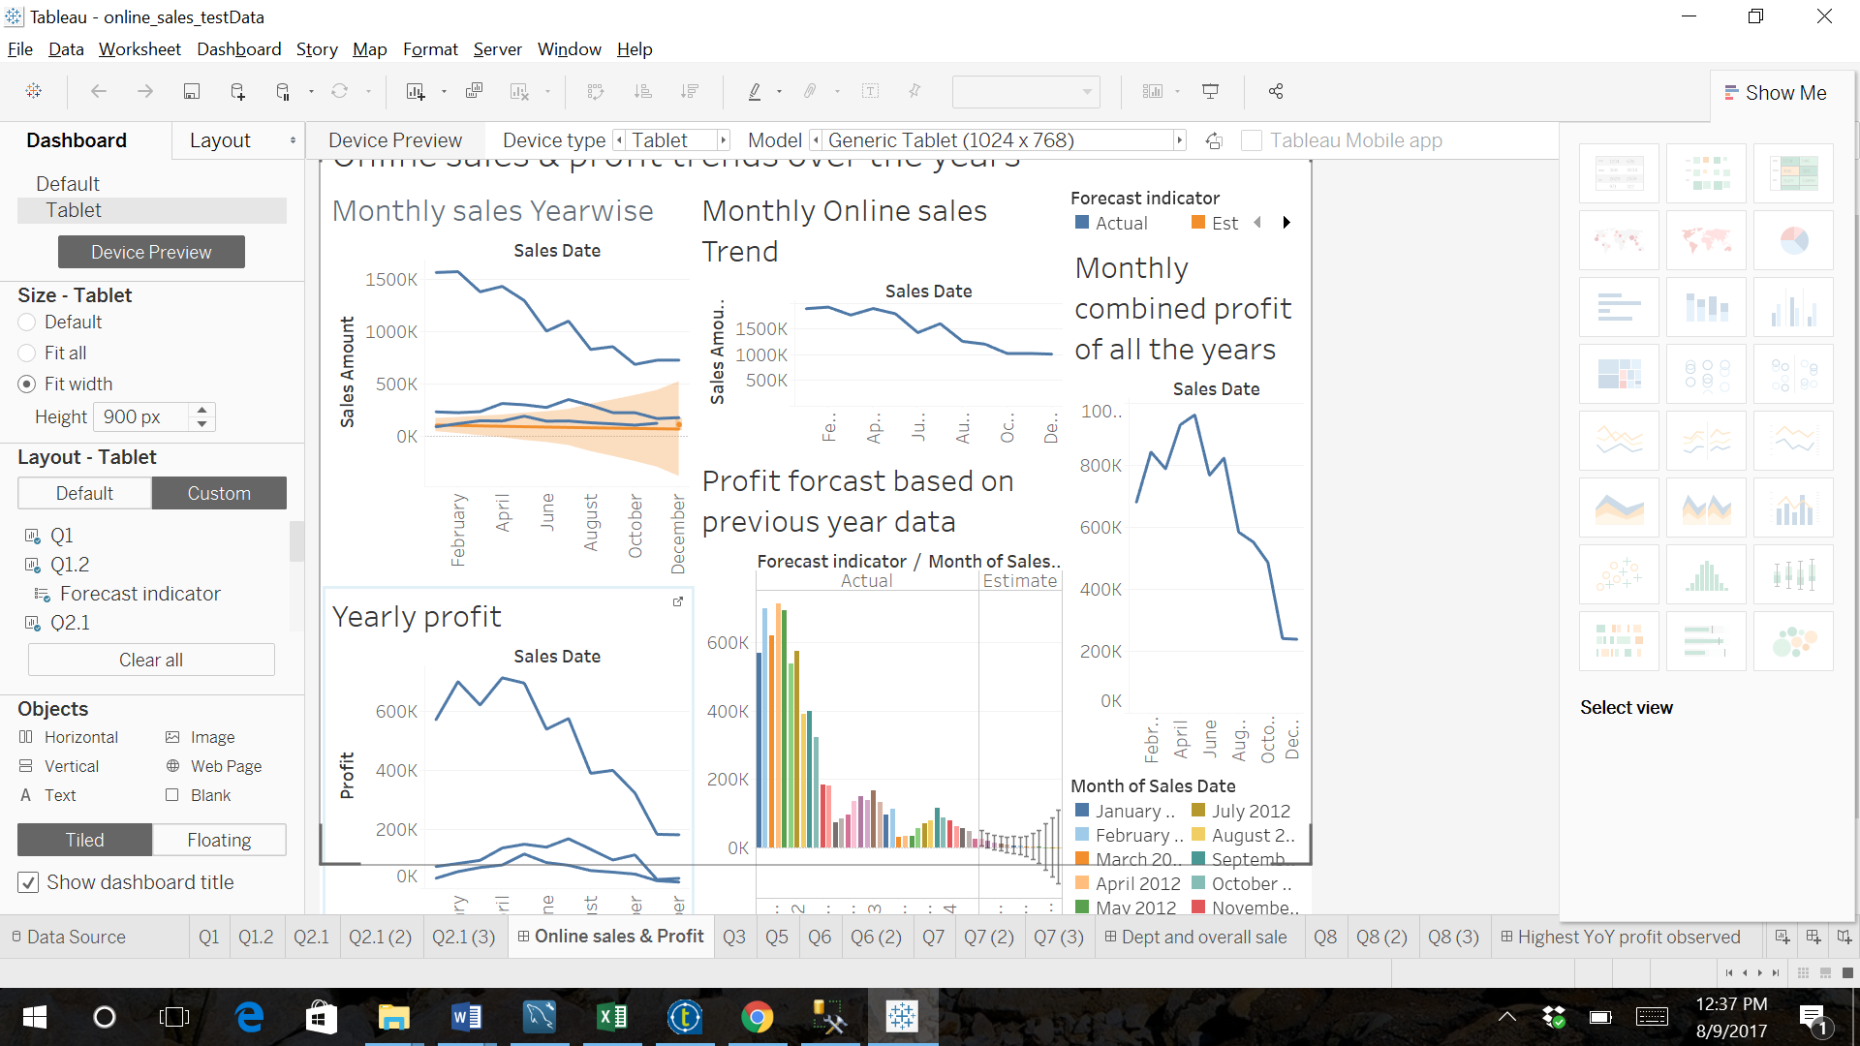

Figure : Dashboard

3.Does the highest sale imply highest profit? Explain with BI.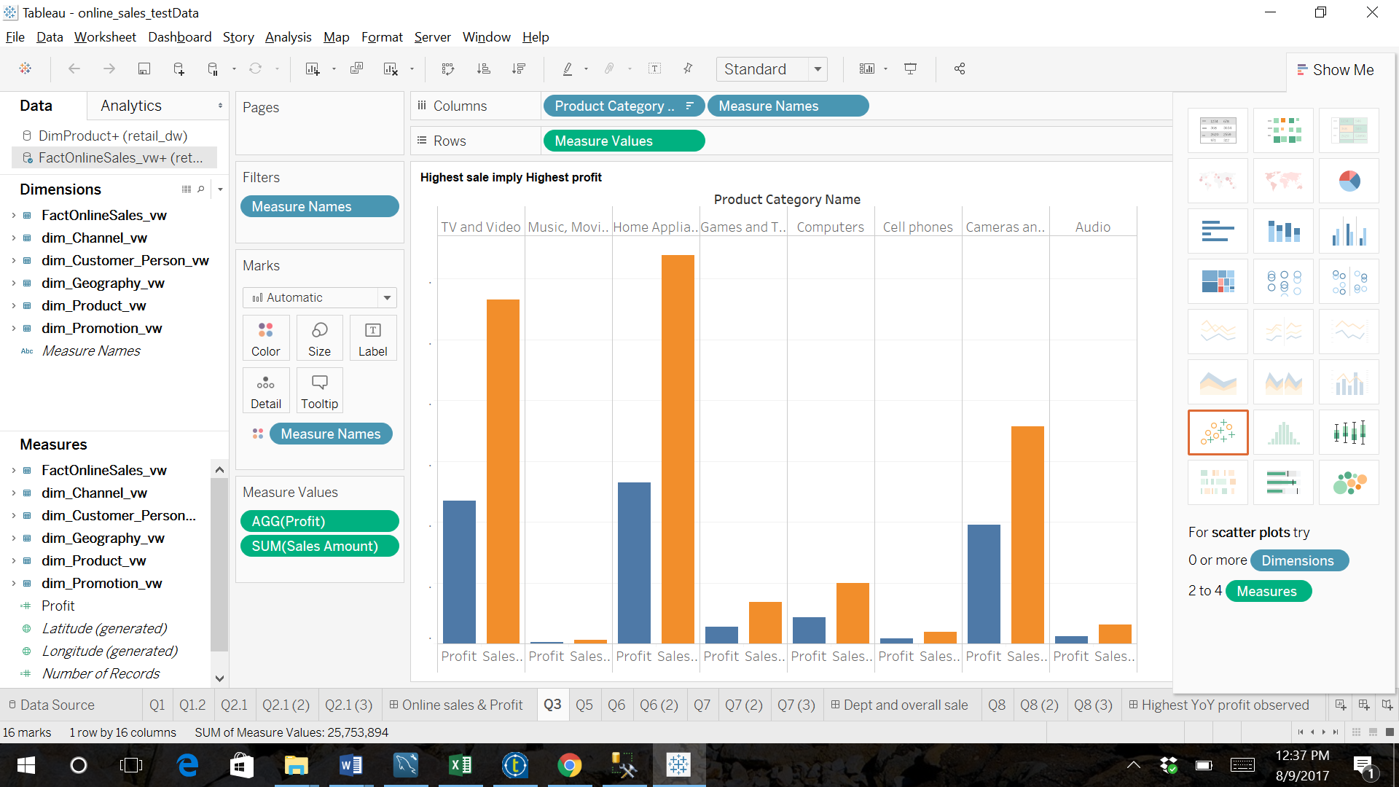

Figure : Highest sales implies highest profit

5.What are the top ten departments/brands for average sales over each year?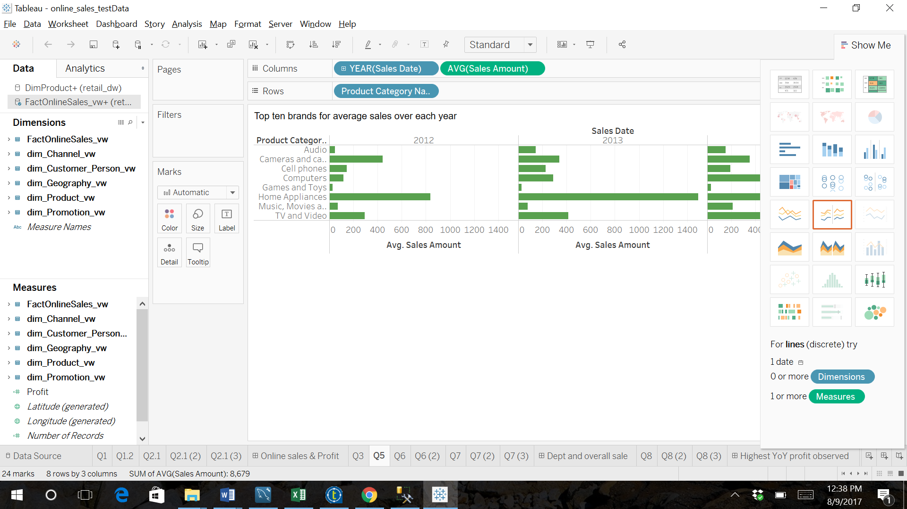

Figure : Top 10 departments for average sales year-wise

6.What is the contribution of these departments to the overall sale?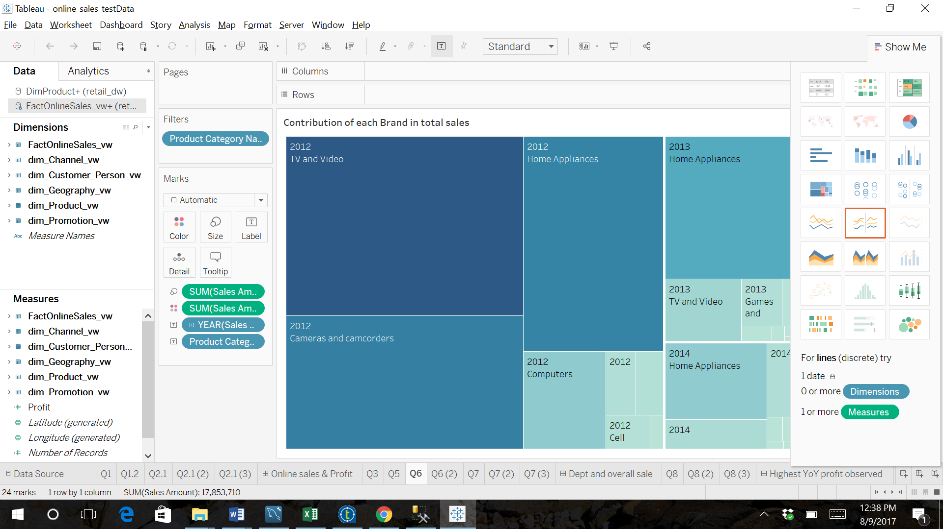

Figure : Contribution of each brand to total sales

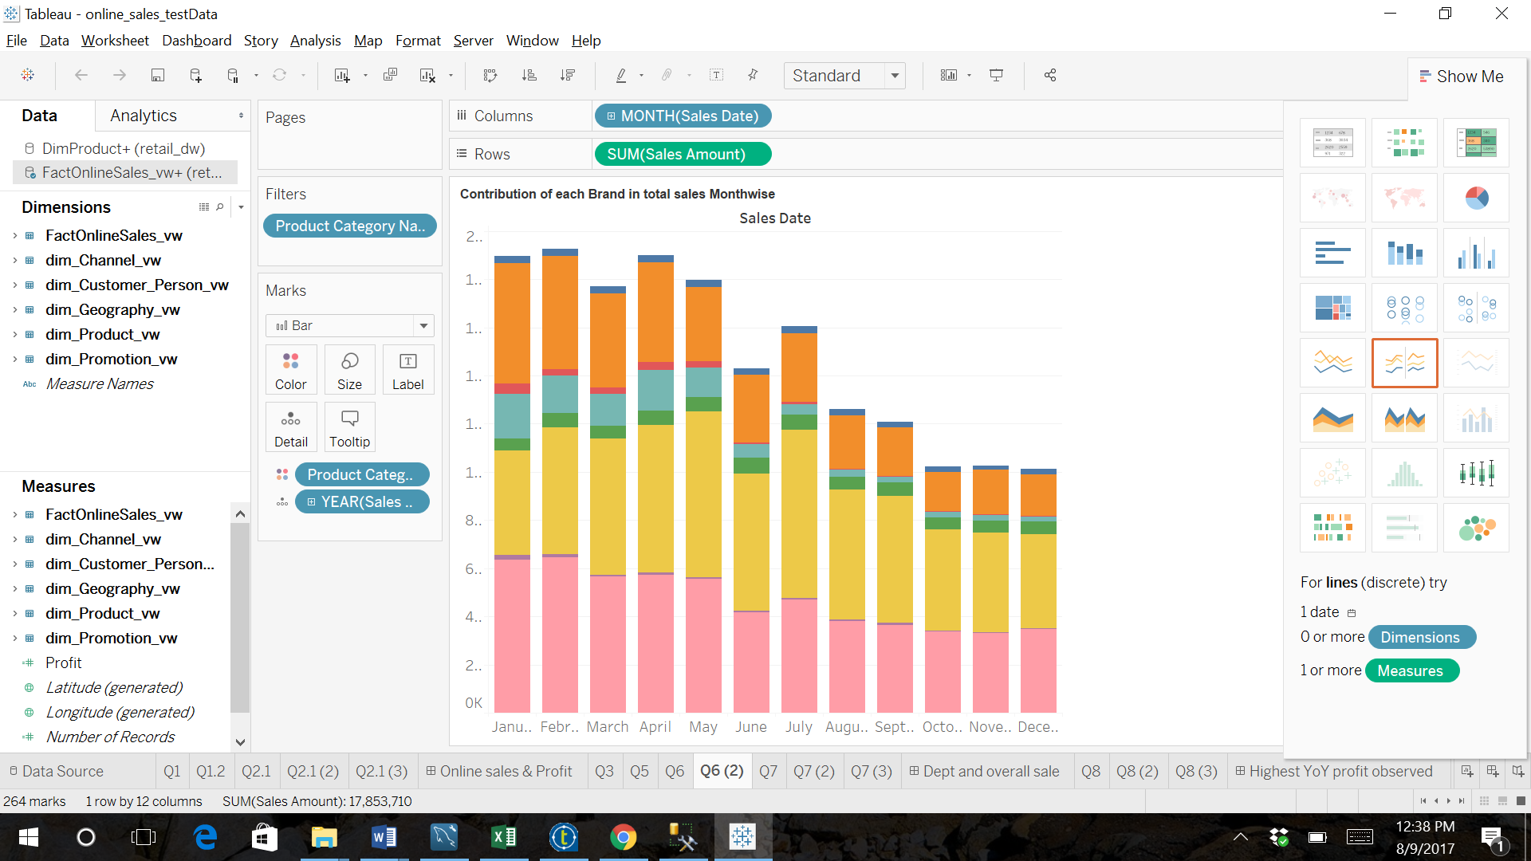

Figure : Contribution of each brand to total sales on monthly basis

7.Which department attracts the maximum customers each year?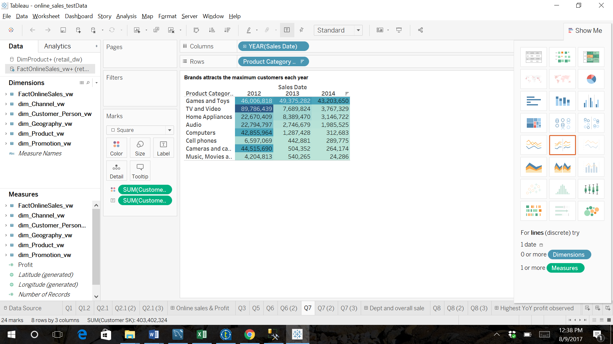

Figure : Year-wise distribution of department attracting maximum customers

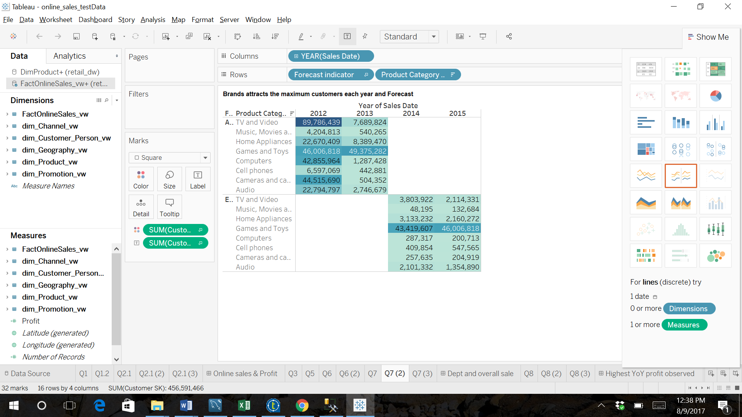

Figure : Forecasting for current and next year based on historical data

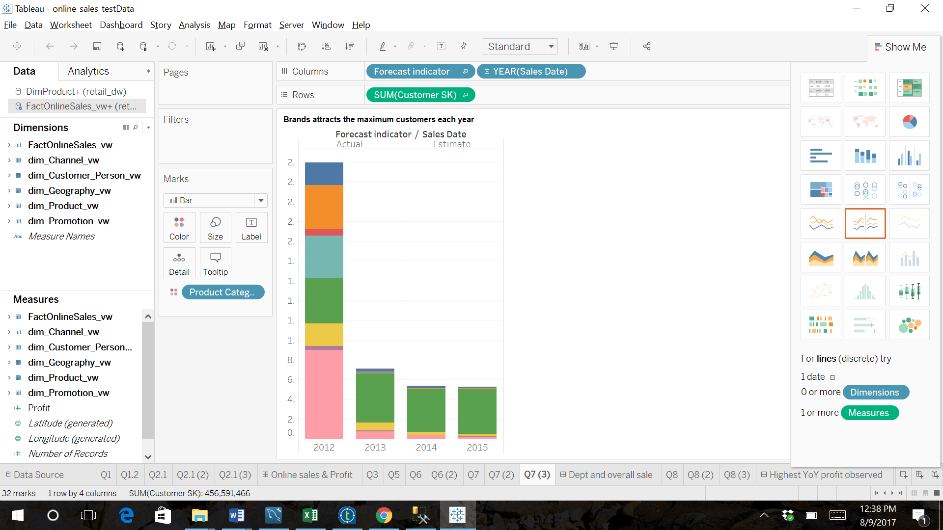

Figure : Brand-wise dirtibution on yearly basis

Dashboard for Question 5, 6 & 7 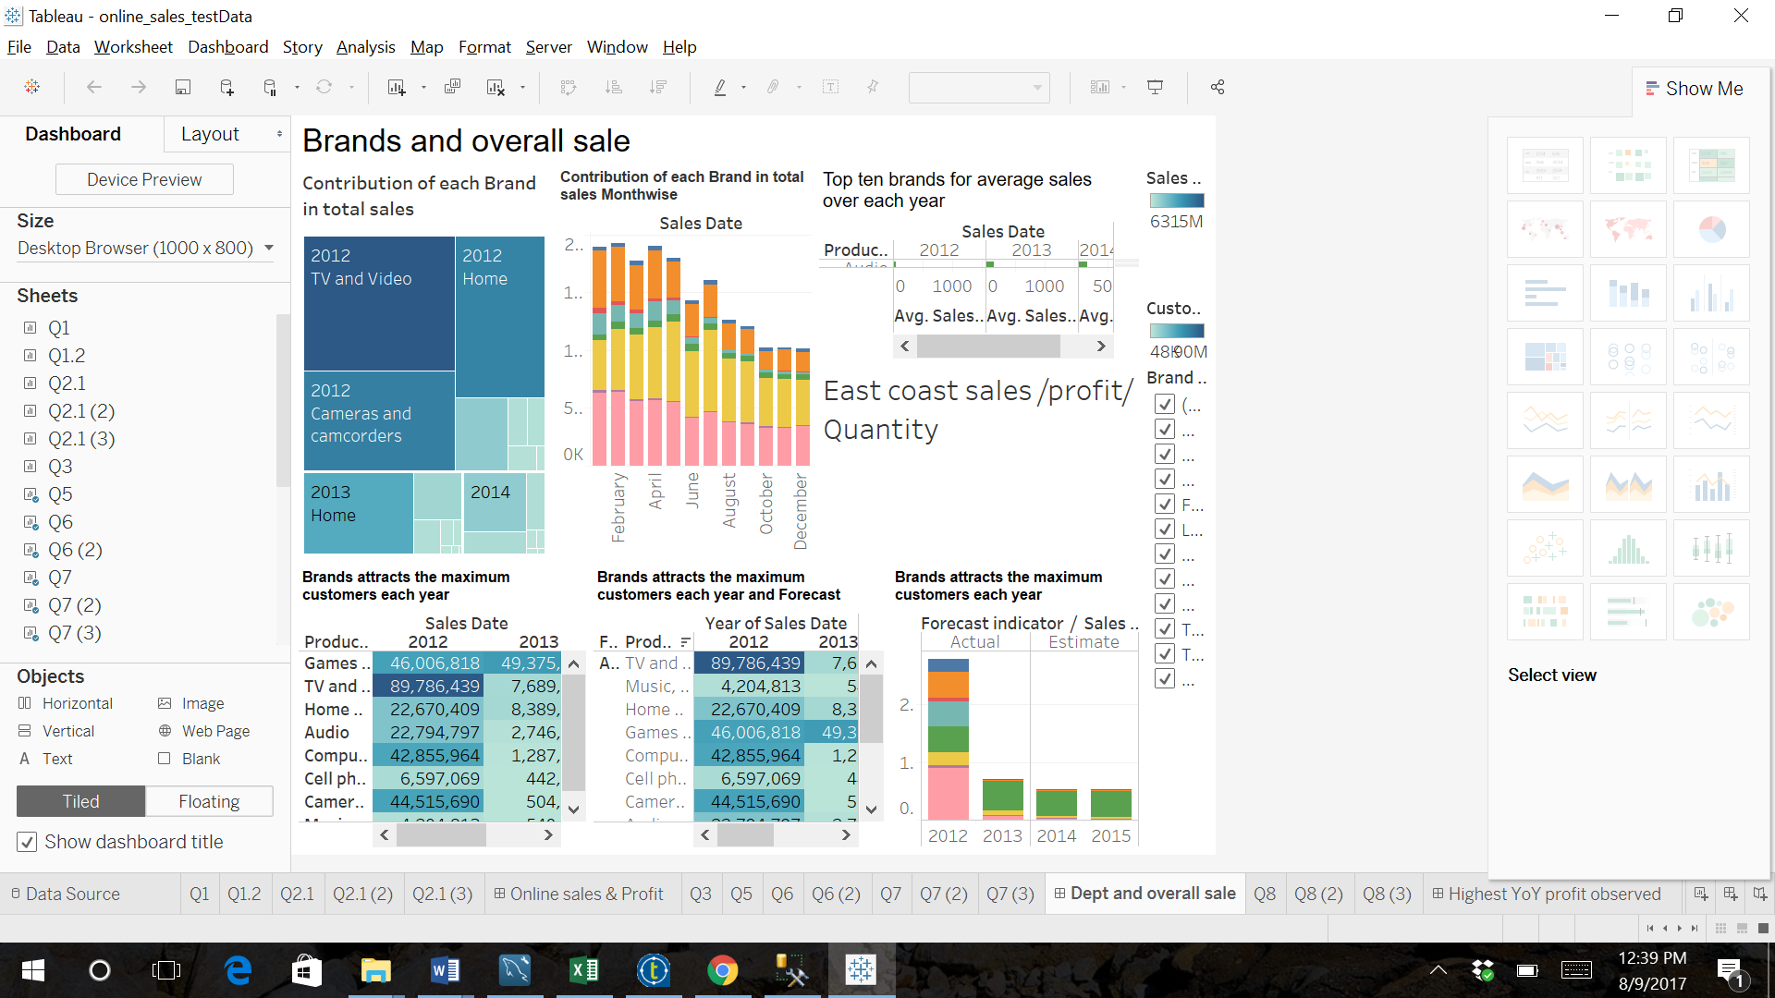

Figure : Dashboard

8.When was the highest YoY profit observed?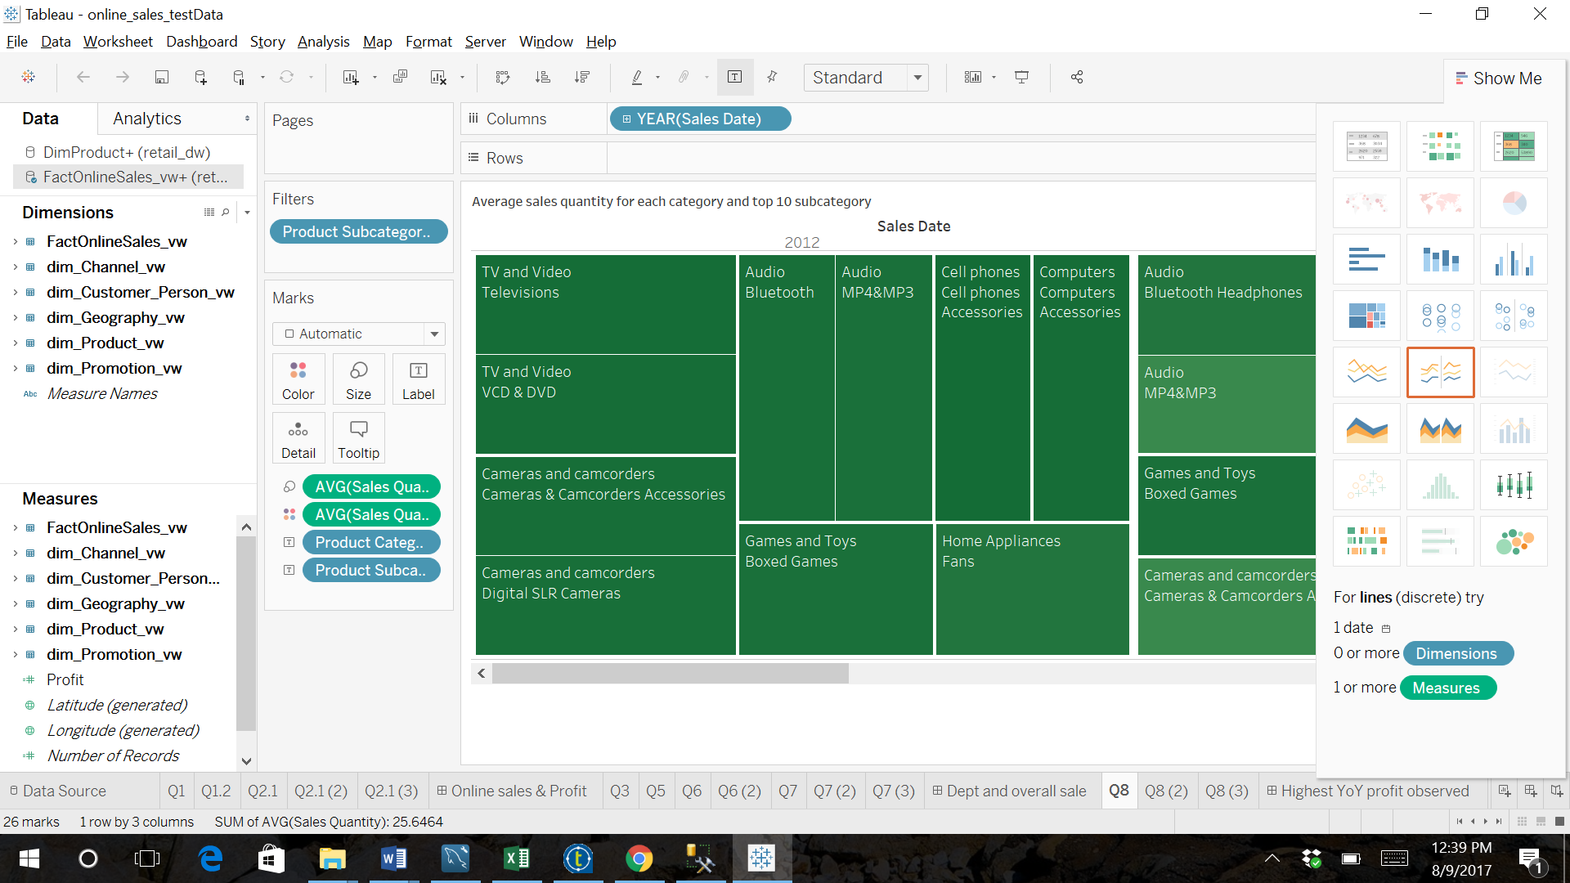

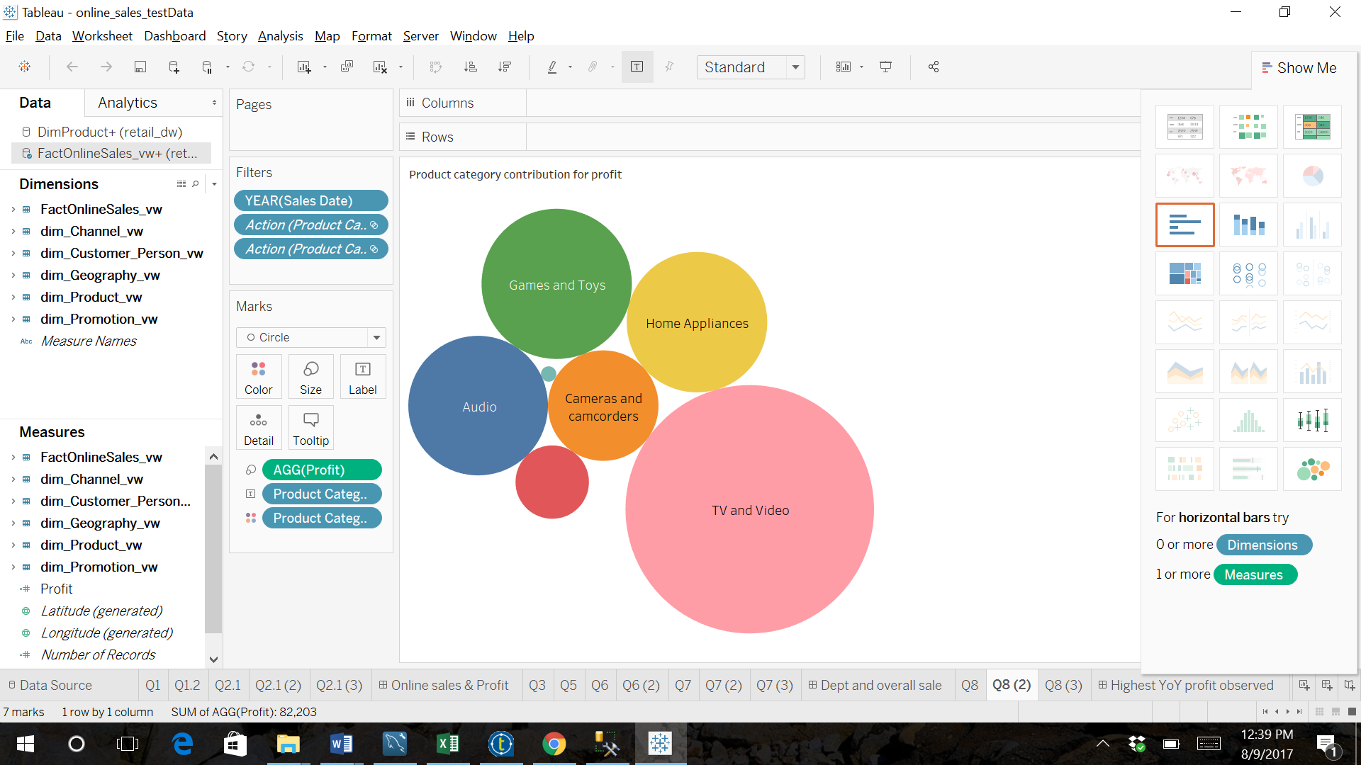

Figure : Product Category distribution for profit

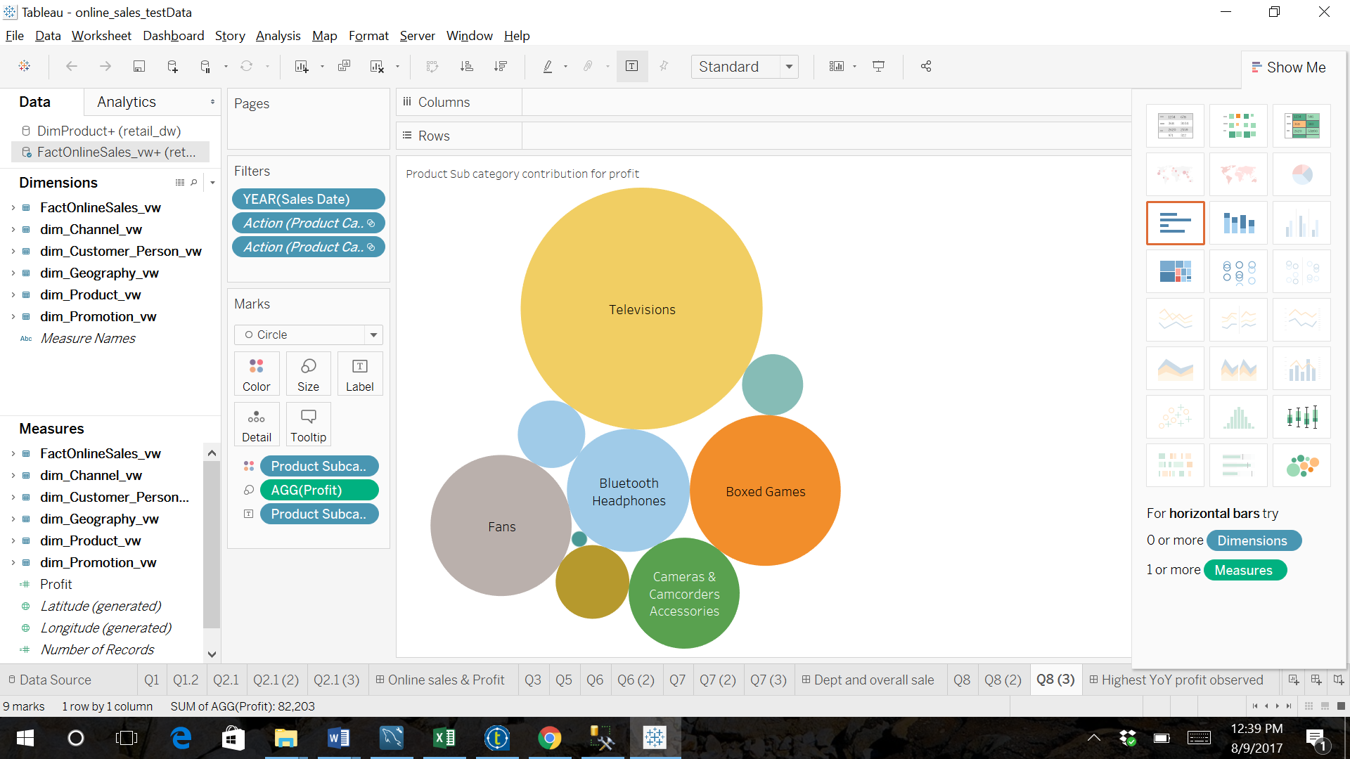

Figure : Product Sub Category distribution for profit

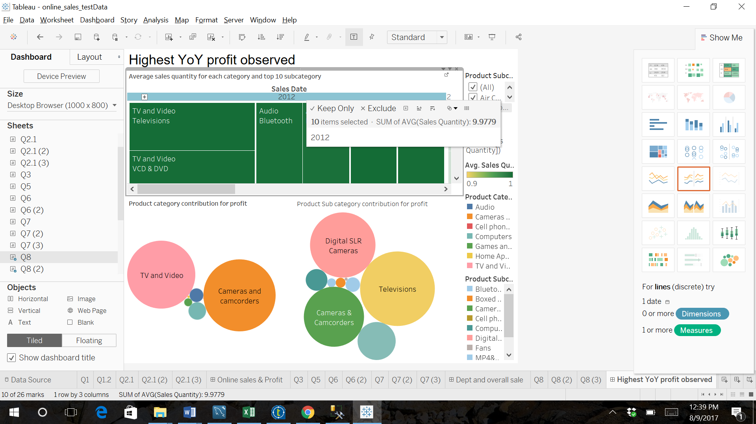

Figure : Year On Year profit dashboard

9.Does the highest selling product of 2014 belong to the same category of highest selling category? Is this the case every month?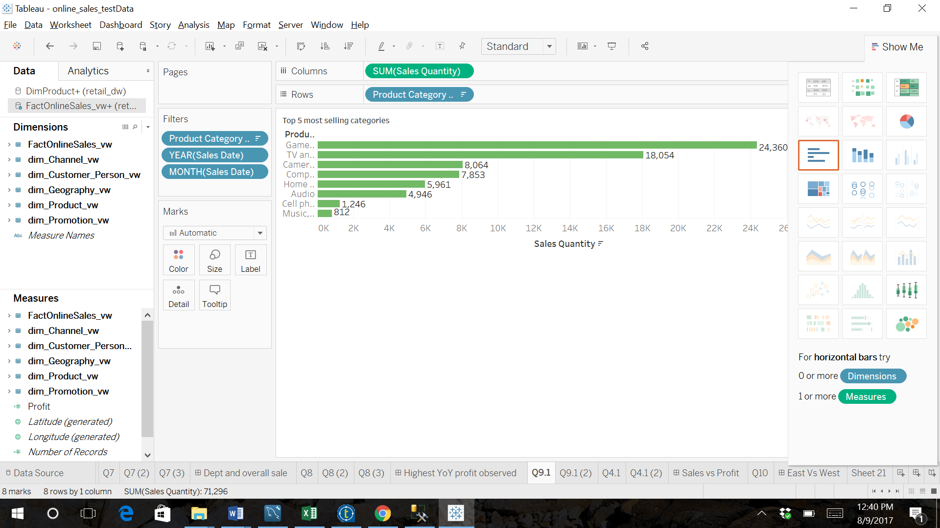

Figure : Top 5 most selling categories

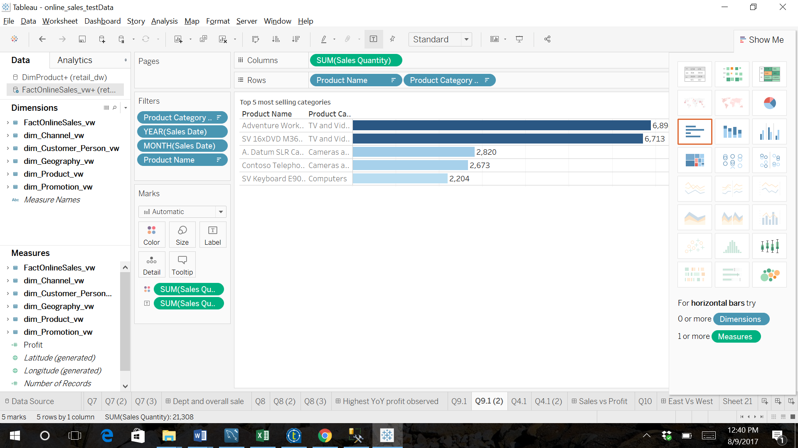

Figure : Top 5 most selling Categories with their Sub Categories

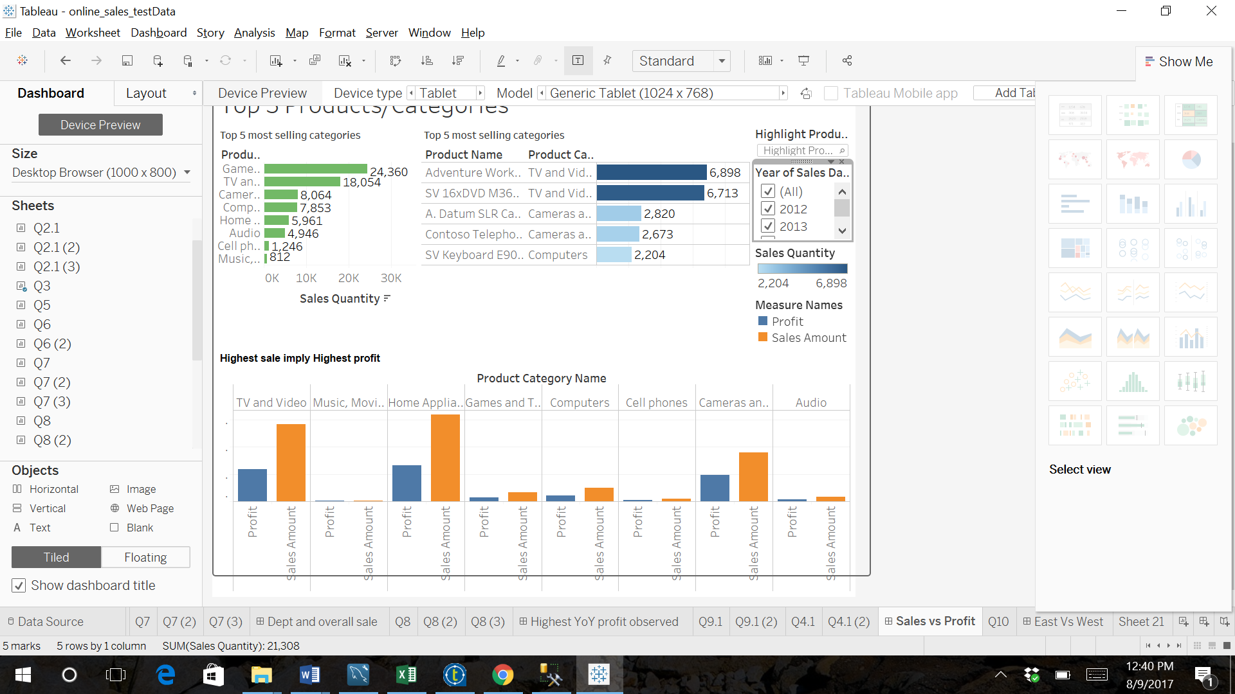

Figure : Dashboard

10.List all products which have undergone a price change more than once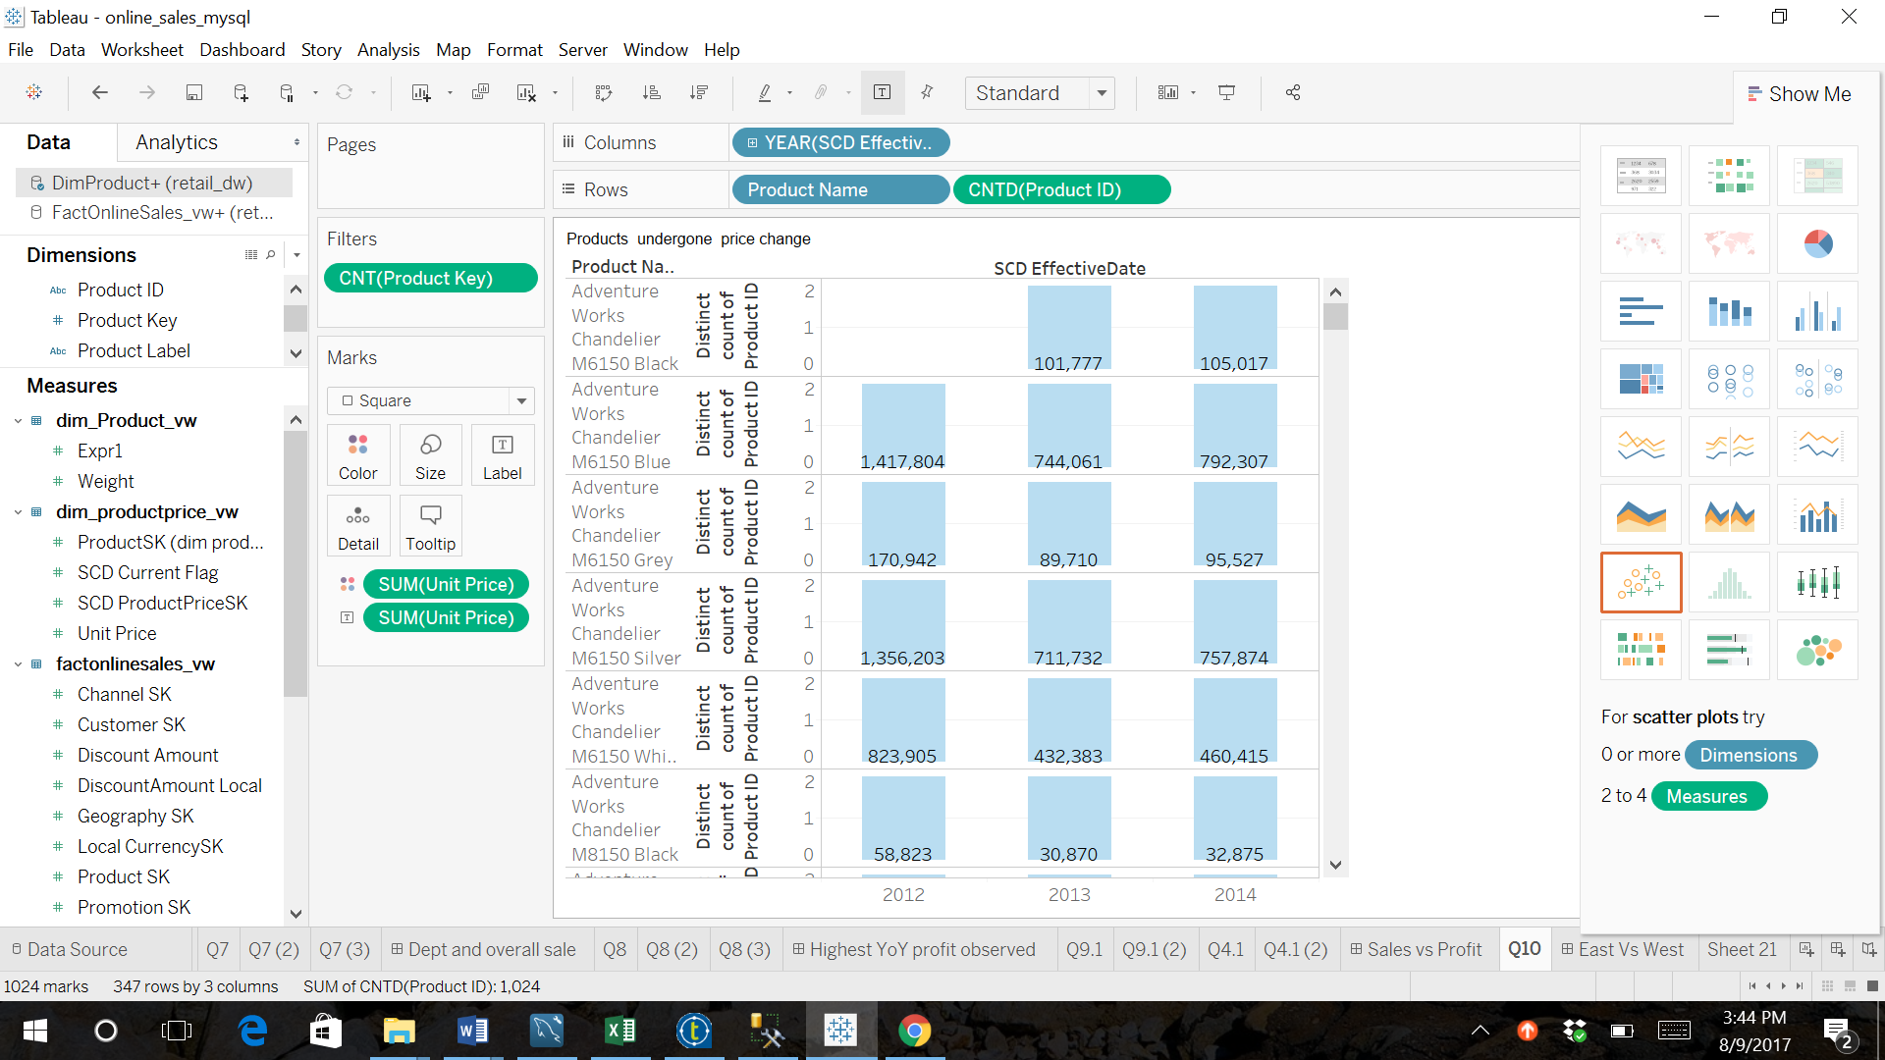

Figure : Product that have undergone a price change

4.Create a dashboard that shows three KPI measures of your choice and compare it across the west and the east coast . Check to see if there is any interesting insights into these varying across customer demographics such as gender and education level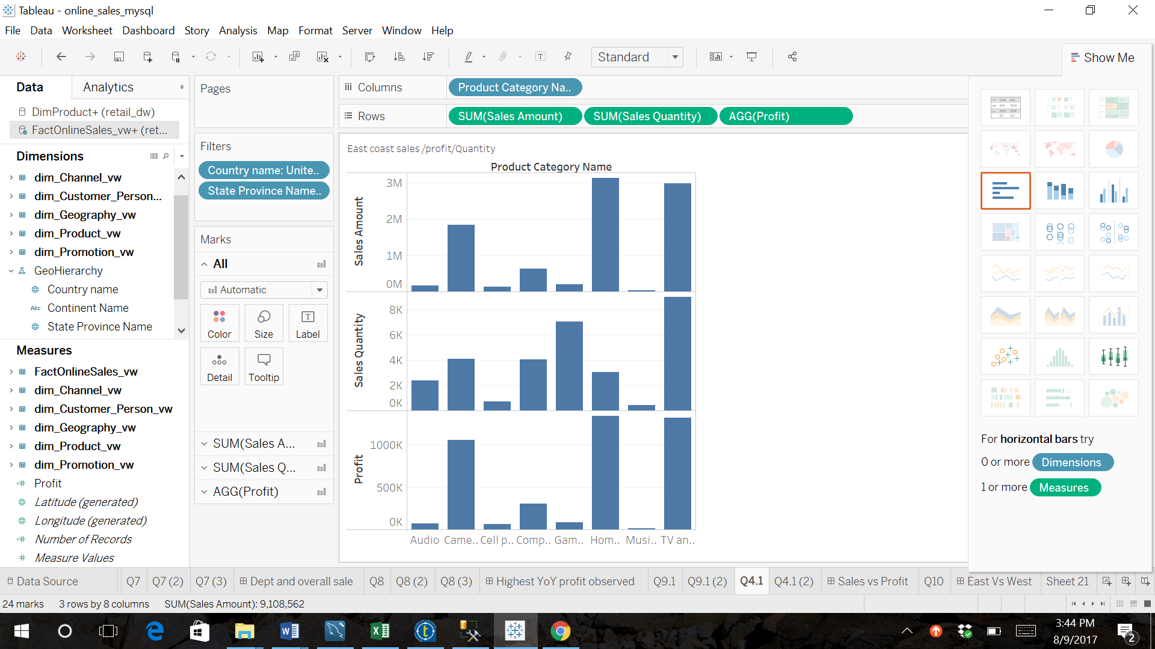

Figure : East coast sales